## BT 3074 - Mathematics for Bioinformatics Assignment 03 Practical Problems – Logistic Growth Model

### Bhagya Wijeratne 15219

Output plot is as follows

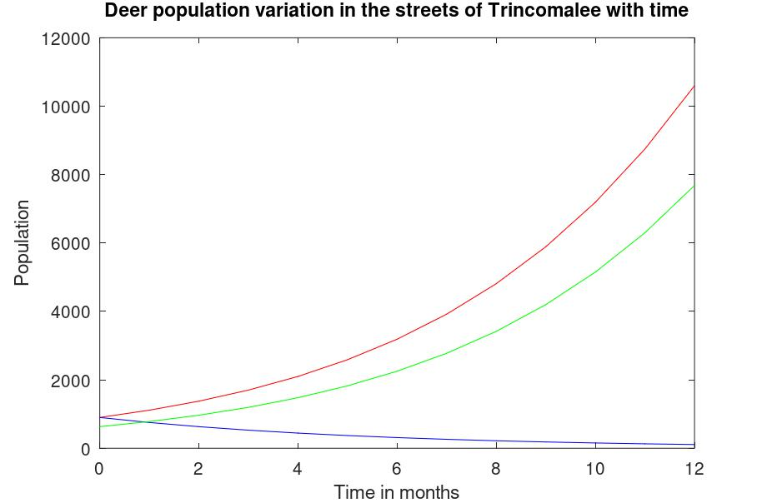

Answer for Question d)

* Based on the values plotted in the command window
* Population by end of August 2024 =
* 5 th Data point for P3 ( starting from end of April)

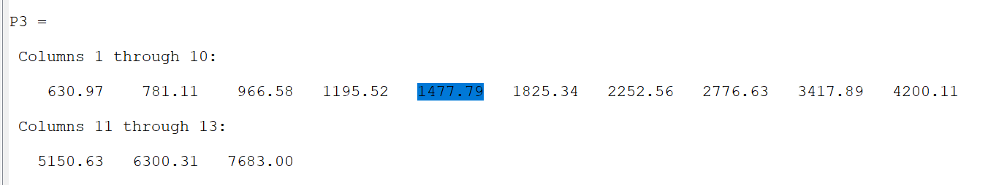

# Answer = **1477.79**